Beginning Conditional Statements with Drop Down Boxes
Program #1:
Using the Side/Perimeter of a Square program as a model, create a program to determine the Radius/Area of a Circle.
The Math class has two mathematical “goodies” that you will need to use.
Math.PI will allow you to use the value of PI as a constant.
Math.sqrt(a double value) will compute and return the square root of a number.
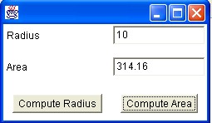
Program #2:
You have been hired by the “Hola, Americano Bank” to prepare a program to convert US dollars to pesos.
$1 is approximately 10.8 pesos.
Prepare a drop down box that will covert dollars to pesos and will also convert pesos to dollars
